ECEN 340
Lab #1

Logic Fundamentals

Purpose:
- To experience the construction of NAND and NOR gates at a transistor level.
- To use signal generators and oscilloscopes to make timing measurements.

Procedure:
Part 1 – Use discrete NMOS and PMOS gates to build and test a NAND gate and a NOR gate.

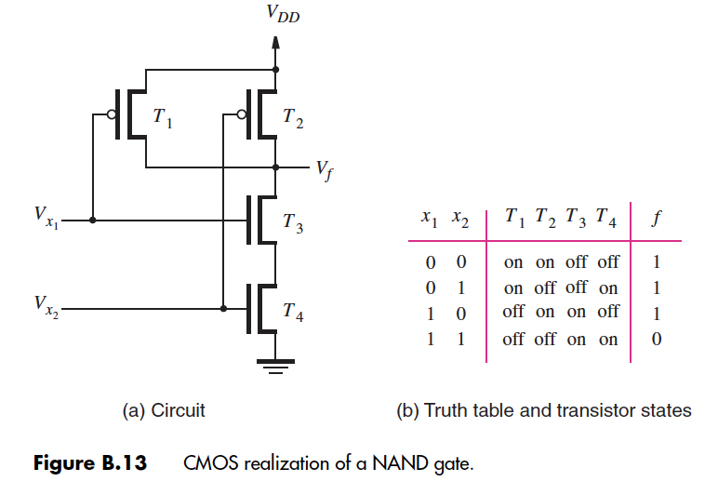

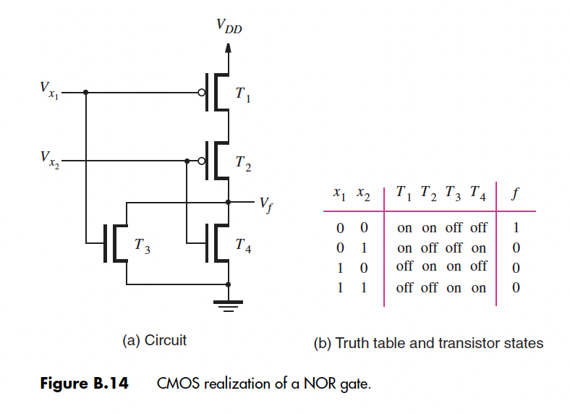

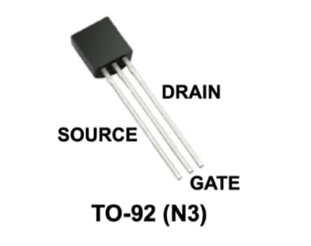

Notes on transistors:
- The PMOS transistors are part number TP2104. This part number is cut into the face of the transistor by laser but is hard to read. To help identify the PMOS transistors, the top has been painted red.
- The NMOS transistors are part number VN2106.
- It is critical that the source and drain be connected correctly (they are not interchangeable). The source of the PMOS transistor is always closest to the power supply, while the source of the NMOS transistor is always closest to the ground.

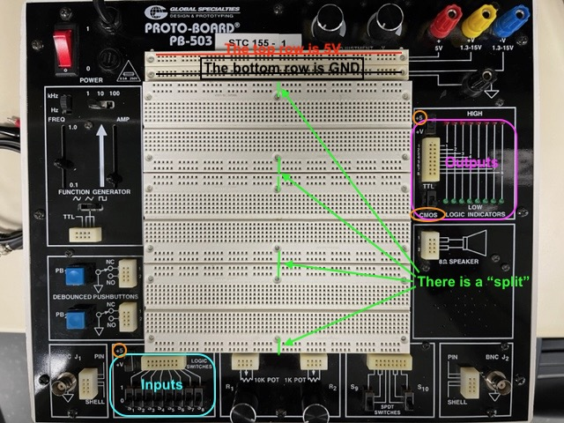

NAND Truth Table Verification:

x₁ | x₂ |  | f
0 | 0
0 | 1
1 | 0
1 | 1

NOR Truth Table Verification:

x₁ | x₂ |  | f
0 | 0
0 | 1
1 | 0
1 | 1

Part 2 – Measure the output rise time, fall time, and propagation delay of a single 74HC04 inverter.

Equipment needed:
- Oscilloscope with 200MHz analog Band Width
- Two 10X oscilloscope probes
- BNC to BNC cable
- BNC to alligator clip cable
- Proto-board system
- 74HC04 hex inverter IC
- Signal generator to generate 1MHz square wave (0V to 5V levels)

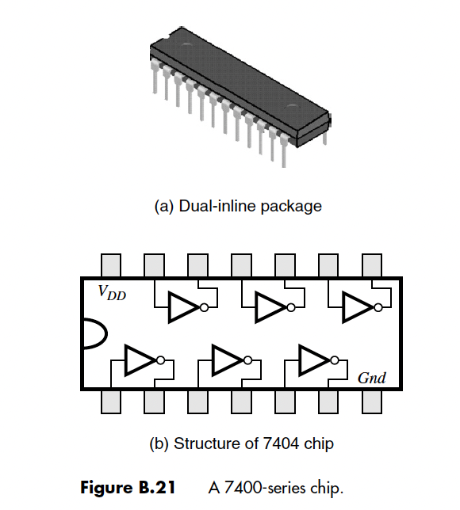

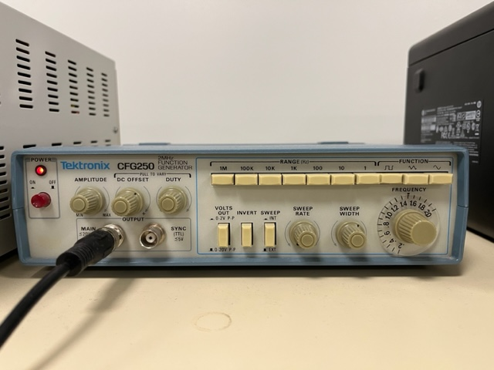
Using the function generator

Connect the function generator to channel 1 of the oscilloscope using a BNC cable. Set the function generator to output a 1MHz square wave. Typically, the output will be centered around 0V. Pull out the DC offset knob so you can adjust the offset and amplitude to swing from 0V to 5V.

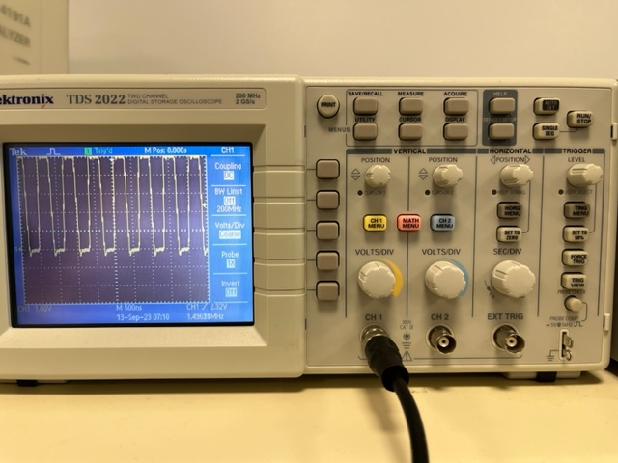
Using the oscilloscope

Tips on Using the Oscilloscope

An oscilloscope probe typically divides the signal by 10. Therefore, the oscilloscope needs to be in the 10X mode to regain the attenuated signal. Some oscilloscope probes have a switch that selects between 1X and 10X. Which setting should you use?

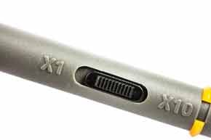

Use the 10X setting for this measurement. The 1X setting will add about 110pF of capacitance and 1MΩ of resistance to the circuit it touches! The additional load capacitance will make the measurement look slower than it really is!

The 10X setting will add 1pF of capacitance and 10MΩ of resistance. The 10X probe has less detrimental impact on the circuit, but the oscilloscope must be set to 10X so that the measured voltages will be correct.
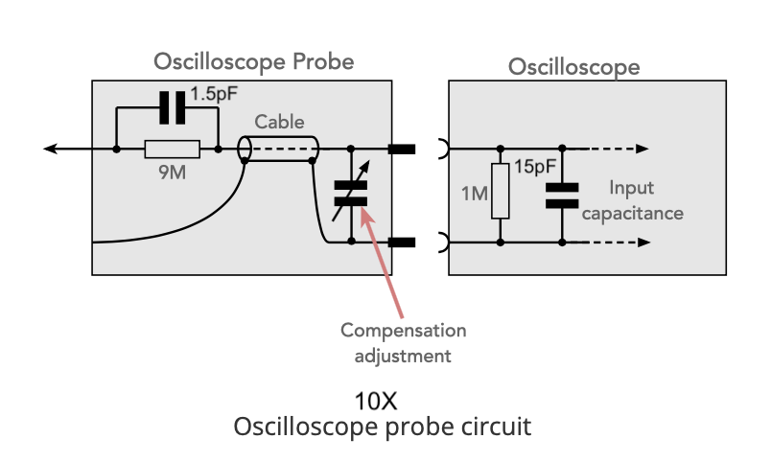

When using a cable as an input to the oscilloscope, make sure the scope setting is set to 1X (press the yellow “Ch 1 Menu” button, then select 1X). Also, make sure the scope is set to “DC” mode, so you can appropriately adjust the signal levels to be 0V to 5V.

The position of 0V on the scope grid is adjustable with the “POSITION” knobs. You can temporarily change the scope from “DC” mode to “Ground” so you will know where 0V is on the grid. Move this to 0V point to the desired location, then change the setting back to “DC” mode.

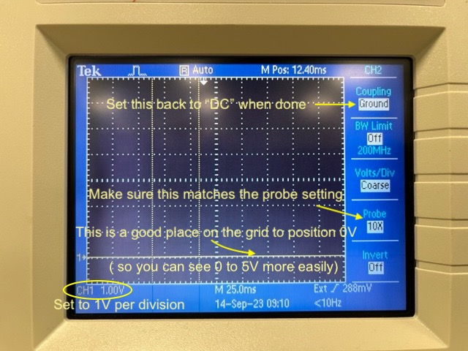

Sometimes the scope can’t “find” the signal. This is usually a timescale, voltage scale, or trigger problem. To solve:
- Adjust the volts per division knob.
- Adjust the vertical position knob.
- Adjust the seconds per division knob.
- Select the trigger menu and make sure you are triggering on the right channel.
- Adjust the trigger level.

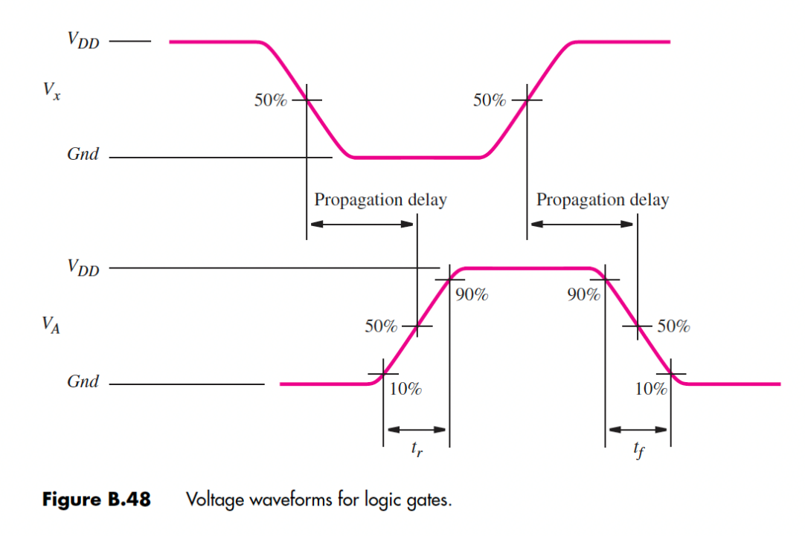
Rise and fall times are measured from 10% to 90% and 90% to 10%. Use an oscilloscope probe to measure the rise and fall times of any of the inverter outputs.
Zoom into the “edge” of the output signal by adjusting the “seconds per division” knob until you can accurately make a measurement.
Use the cursors to make an accurate measurement. When in cursor mode, use the two position knobs to adjust the cursor positions.

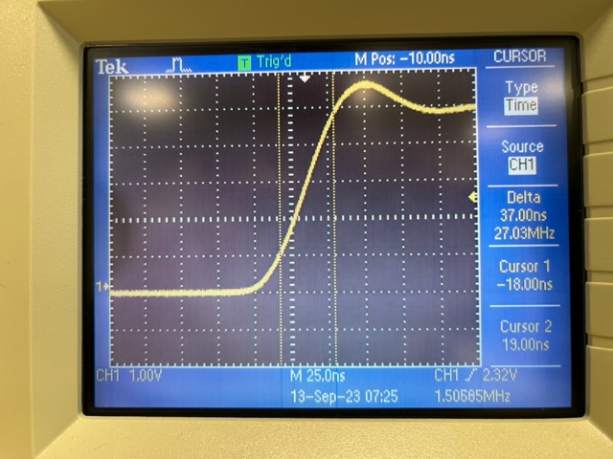
Cursor Mode Settings

Propagation delay measurements are made from the 50% point of the input to the 50% point of the output.
The rise and fall times of the signal generator are much slower than the rise and fall times of the inverter outputs. It is more accurate if you connect all 6 inverters in series and measure the delay from the 50% point of the input of the first inverter to the 50% point of the output of the last inverter. Divide this by 6.

74HC04 Timing Measurements
Rise time of any inverter output
Fall time of any inverter output
Prop Delay of all 6 inverters
Prop Delay of single inverter (divide the above measurement by 6)

Submitting your report:
Submit a combined report for both parts of this lab which should include the following:

1) Completed measurement tables with comments (5 pts).

2) A brief description of the unique (new) tools, technologies, or methods used to implement this lab (5 pts).

3) Images of your completed circuits and images of the waveforms seen on the oscilloscope for each of the three measurements (5 pts).

4) The report should be professional quality—meaning it will be neat and use proper English (5 pts).

5) In your conclusion statement, discuss your results, the method of testing, and include the level of functionality of the lab (a percentage would be fine, 5 pts).

